

Structural Design

(Inside View)

**Vertical corrugation**

Design#:

13*/*8

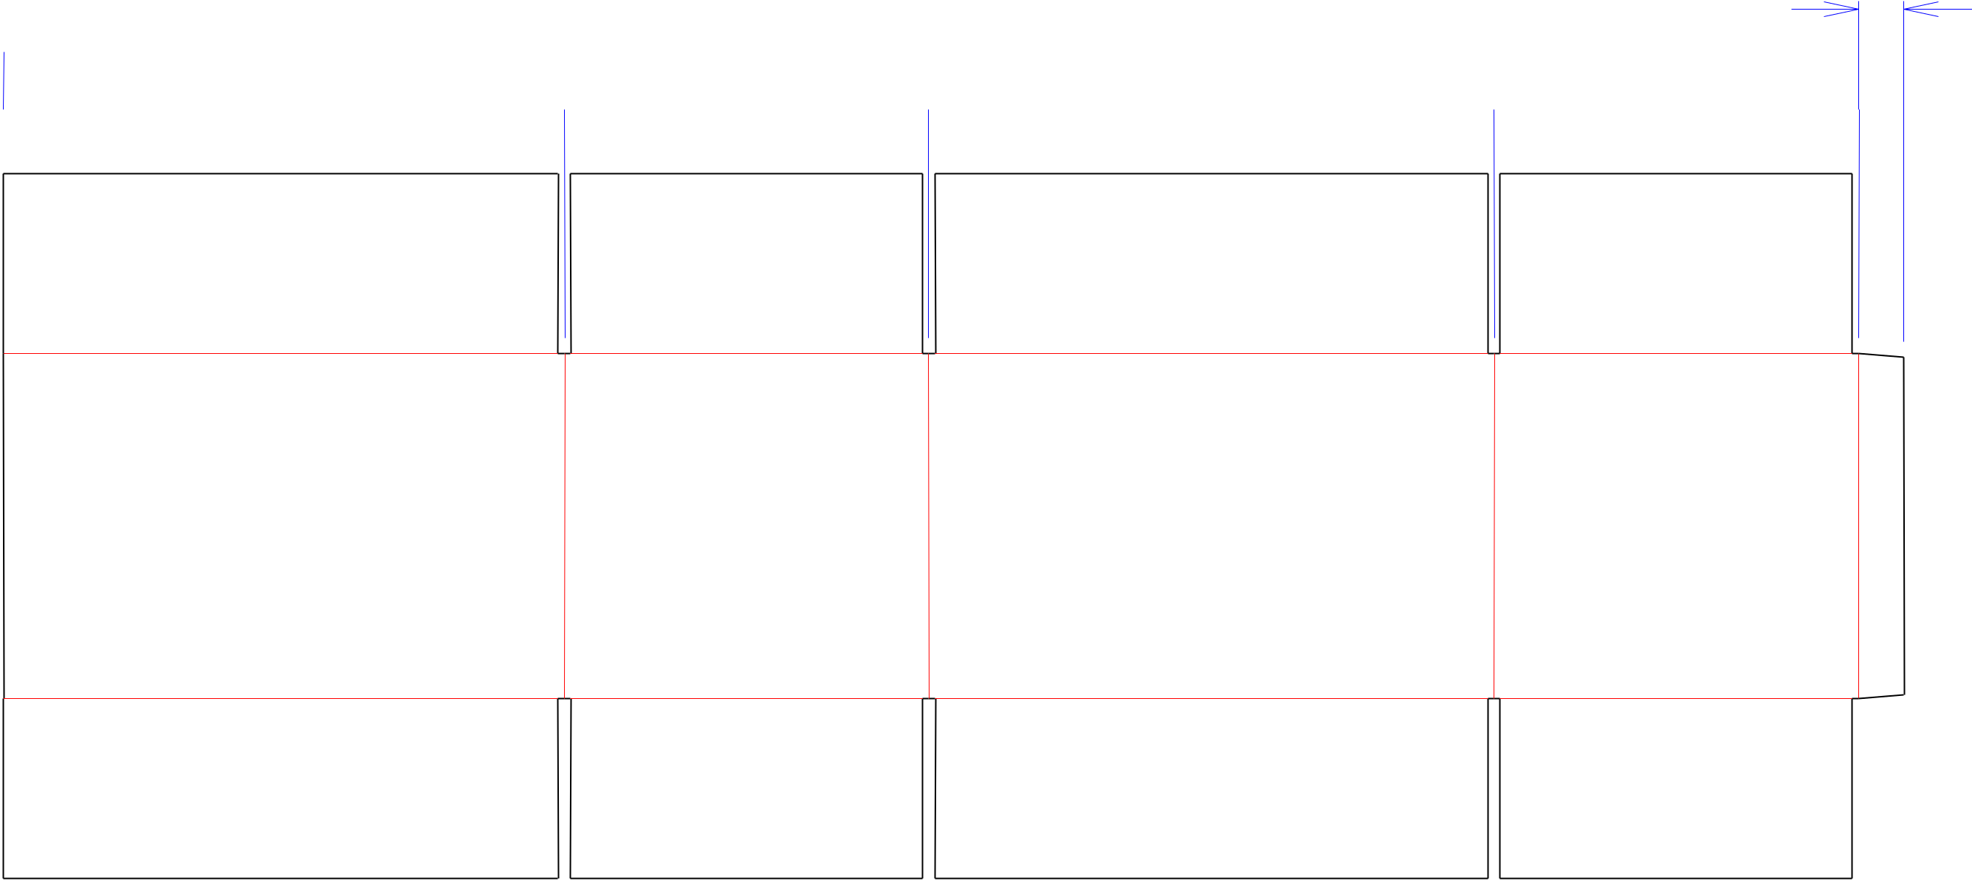

 573*/*8 

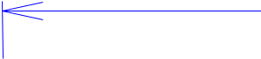 1615*/*16  11  171*/*16  11 

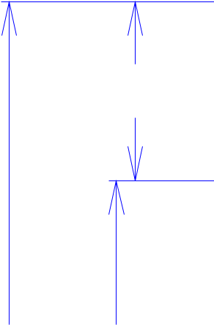

57*/*16

215*/*16 107*/*16

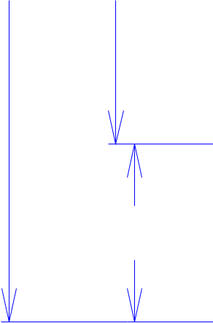

57*/*16

**140779-02_A**

Customer:

**DeMet's Candy**

Description:

**RSC.610/3 new orientation 9001728**

**SINGLE-OUT DRAWING**

Qty/Unit:

Style: **RSC**

Board: **32BK**

Combination: **35HP - 23M - 35HP**

I.D. : **16+15/16 x 10+7/8 x 10+3/16**

Area of Blank - Waste : **8.29 sq. ft.**

Waste on Blank : **2.4%**

Finished Piece Weight: **0.85 lbs./387.65g**

Over-all Blank: **21+5/16 x 57+3/8**

Notes:

**Product slides in from side (endload) -**

**shipper is shipped with opening on top**

**and product on it's side**

Revision Info: **[A] 07/02/2019**

**new orientation**

Designer: **Alan Groff**

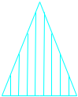

Cut Crease Crease with Matrix Cut Crease Half Knife Cut Tear Tape Perforation



Designright and Copyright of DS Smith Corrugated Packaging Ltd. This technical Specification is subject to Manufacturing tolerances. Drawing dimensions shown are crease to crease. Date printed: 07/18/2019